Scrolling text with speed control and button. Wired to Uno R3.

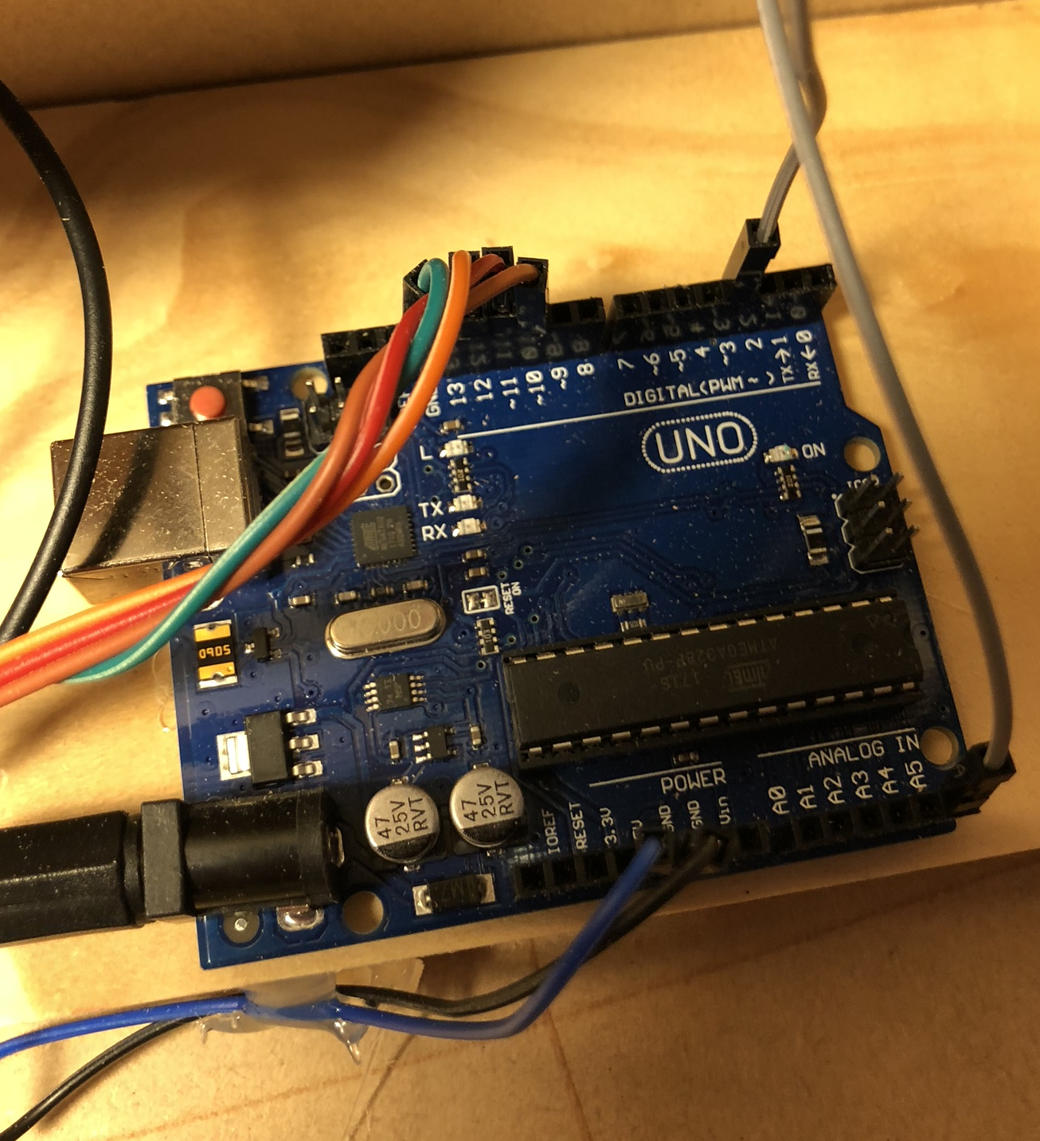

Wiring:

BUTTON
Pin 3 -> button (with 10k resistor pulling it up to 5V if open, closed = grounded).
Should have used pinMode(mPin, INPUT_PULLUP); then could have left off the resistor!

POTENTIOMETER

Pin A5 (analogue pin) -> 10k pot center tag. 0v and 5v at either end.

Maps to 0 (0V) to 1024 (5V) via analogRead(A5);

MAX7219 8x8 matrices

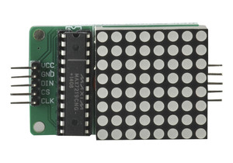

wiring multiple together. Need to change constant in jscoll.h:

#define MAX_DEVICES 2

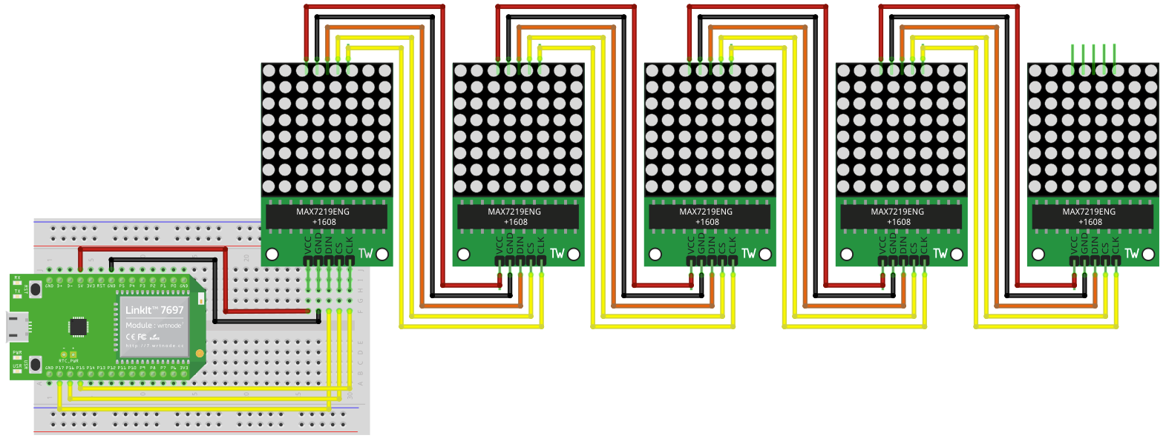

On Uno currently wired as:

CLK_PIN -> 10 [aka SCK]
CS -> 11 [aka SS]
DIN -> 12 [aka MOSI]

Normally Uno has Mosi 11, MISO 12, SCK 13 and SS 10. :/ But the above mapping seems to work.
https://www.arduino.cc/en/Reference/SPI
Future ideas:

Should be able to move the pot to A1, then use A4 as SDA and A5 as SCL and connect the 16x2 LCD.

Should also be able to connect keypad on digital pins [2,4,5,6,7,8,9,10,13] but then no pins for buzzer. :/ Could get rid of button and put buzzer on instead.

Could connect joystick via one digital and two analogue. And servo by another digital.

